COVID-19 TABLEAU ANALYSIS
Aniket Gupta
3009300
Griffith college
Data variable(s)
There are 5 data variable(s) in the COVID-19 dataset selected which are namely Province/State, Country/Region, Date, Confirmed, Death, & Recovered. Province/State variable is the province of the COVID disease. Country/Region variable depicts the country of COVID disease. The date variable shows the date of COVID cases ranging from January 22, 2020 to May 6, 2020. Confirmed variable depicts the confirmed cases of COVID-19. Deaths variable show the COVID deaths that has occurred. Recovered depicts the number of COVID patients that have recovered.
Understanding of variables
The variables represent the COVID cases registered in various countries/regions and the province of COVID-19 occurrence. They represent the cases confirmed in these countries, the cases that have recovered from COVID 19. It also shows the number of COVID deaths that have occurred in the different countries. They provide a comprehensive overview of the COVID 19 cases registered.
Relation of the variable(s)
The variables on the dataset are related to each other. The province is in the country where the COVID case is registered. The variable date is the period when COVID case was registered. It is related to other variables to learn when the first COVID case was confirmed in the province of the respective country. This is related to the recovered and deaths occurred from COVID-19. They are the number of COVID cases who have recovered in the respective province in the country during the specific time period. Likewise, the death variable relative to the dataset depicts the number of deaths that have occurred in the specified date from COVID out of the registered COVID cases in each of province of the respective countries.
EXPLORATORY DATA ANALYTICS
Dashboard 1:
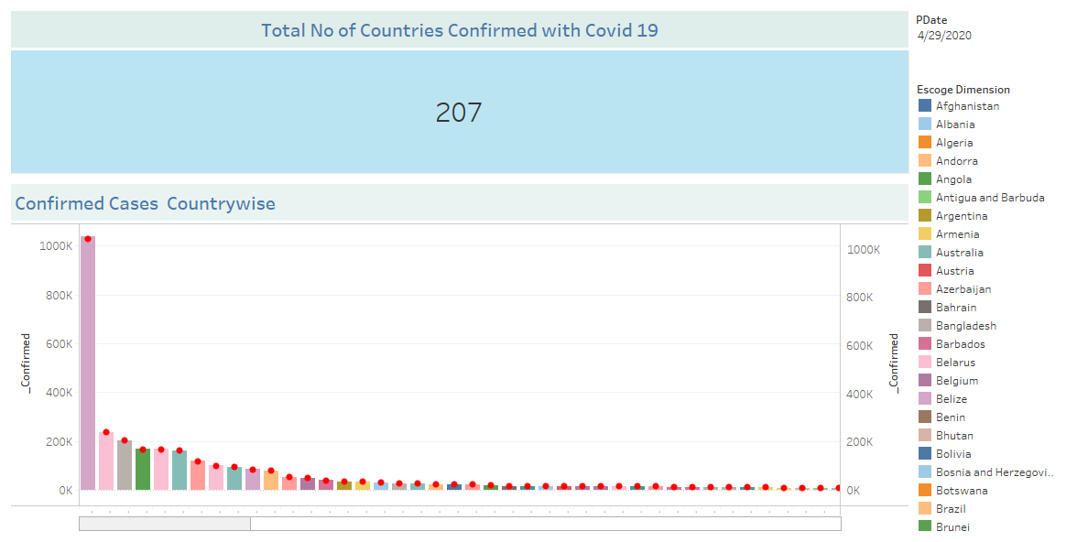
Description: The dashboard depicts the total number of COVID 19 cases registered in different countries. It portrays the COVID 19 confirmed cases by country.
Target audience: The target audience includes the respective healthcare organizations that should focus the country registered with highest COVID cases and help to overcome the health pandemic. It also includes the individuals residing in the country or visiting the respective countries with COVID19 cases confirmed.
Purpose: The purpose of the dashboard is to represent the total number of COVID19 cases that are confirmed in each country. It will inform the countries with higher rate to take adequate precautionary measures for preventing the spread of the COVID disease.
Information presented: The information presented is the confirmed cases of COVID in each country. The cases are represented as columns for each country. This ranges from the highest followed by the lowest number of cases registered and so on.
Actionable insights: The actionable insights gained from the dashboard are that it provides an overview of the COVID cases confirmed worldwide in various countries. With the dashboard, the global health organizations should strive to support the countries along with the government to take precautionary action against the spread of the disease.
Benefit for decision making process: The benefit from the above dashboard to decision making process is that global healthcare organizations can focus on supporting the countries with higher COVID cases registered. Also, it will help to decide the funding to be provided for each country according to criticality of the situation.
Dashboard 2:
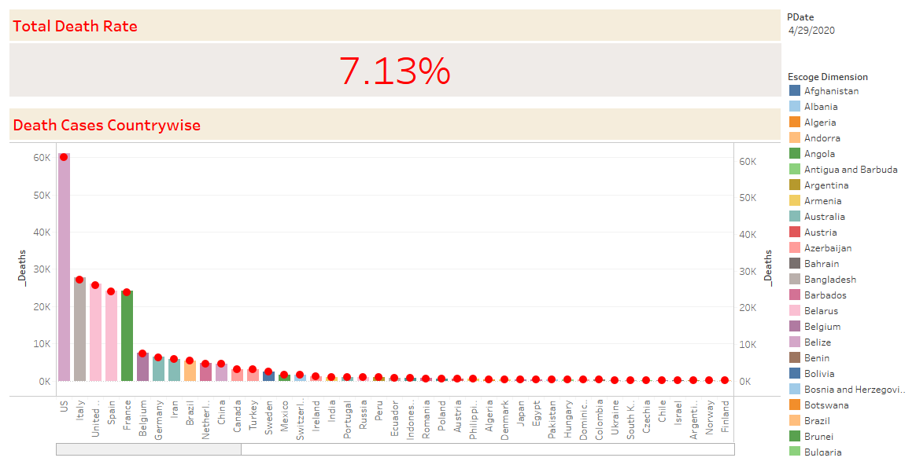
Description: The dashboard depicts the total death rate from COVID 19 registered in various countries. It shows the number of deaths that have occurred in each country represented during the respective time period.
Target audience: The target audience is the health authorities of the country and the other neighboring countries. They should see to the alarming rate of COVID deaths in their country and make the required arrangements to address the pandemic.
Purpose: The purpose of the dashboard is to observe the alarming rates of deaths that have occurred in the countries where COVID has been confirmed. It will show the highest incidences of COVID and in which country.
Information presented: The information represented depicts the number of deaths that has occurred in each of the country during the respective dates.
Actionable insights: The actionable insights gained from the visualization in the dashboard are that U.S., Italy, United Kingdom, and France are the countries recoded with highest COVID19 deaths. These countries should take serious precautionary and prevention measures along with the adequate healthcare to address the problem.
Benefit for decision making process: The decision making process can be benefitted from the dashboard by assessing and learning about the highest incidence of COVID and providing help to these countries in the order.
Dashboard 3:
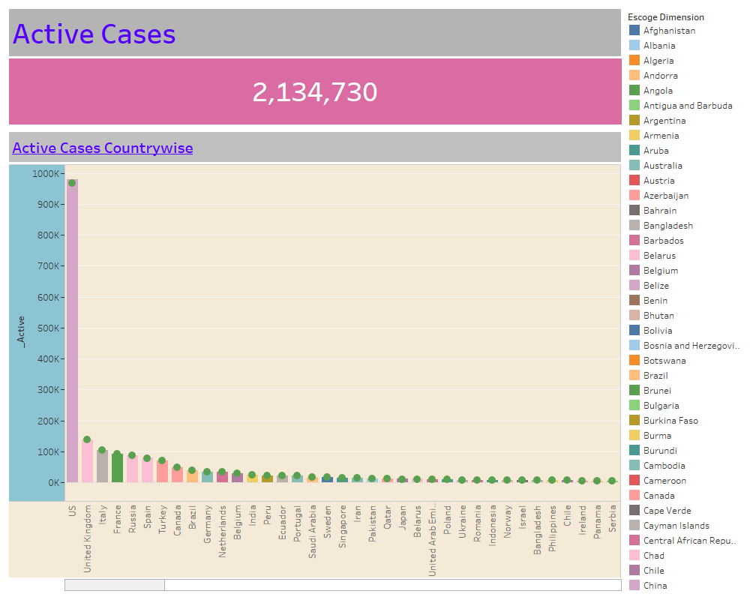
Description: The dashboard shows the current active cases of COVID in different countries of the world. It is a key dashboard as it presents the detail of COVID cases that are confirmed and are currently in treatment.
Target audience: The target audience includes people of the different countries represented in the dashboard. It also includes WHO, government authorities of the country and other health professionals in each of the country.
Purpose: The purpose of the visualization is to depict the deaths that have occurred in each country due to COVID 19. It shows the deaths which happened and the number of deaths in the countries ranging from the highest to lowest deaths registered in the countries.
Information presented: The information presented shows the criticality of the COVID problem relative to the number of deaths in the countries. It depicts the seriousness of the COVID19 spread in each country in terms of deaths that have occurred due to COVID19.
Actionable insights: The actionable insights are to support the countries with highest cases registered to prevent the deaths with provision of adequate medical supplies and healthcare support. The deaths show that United States has the highest threat of COVID at the most extreme level.
Benefit for decision making process: The decision making process will be highly benefitted if the countries with highest number of deaths assess and utilize prevention methods of countries with no COVID deaths. They can also benefit from providing support to these countries based on the severity in terms of death.
Dashboard 4:
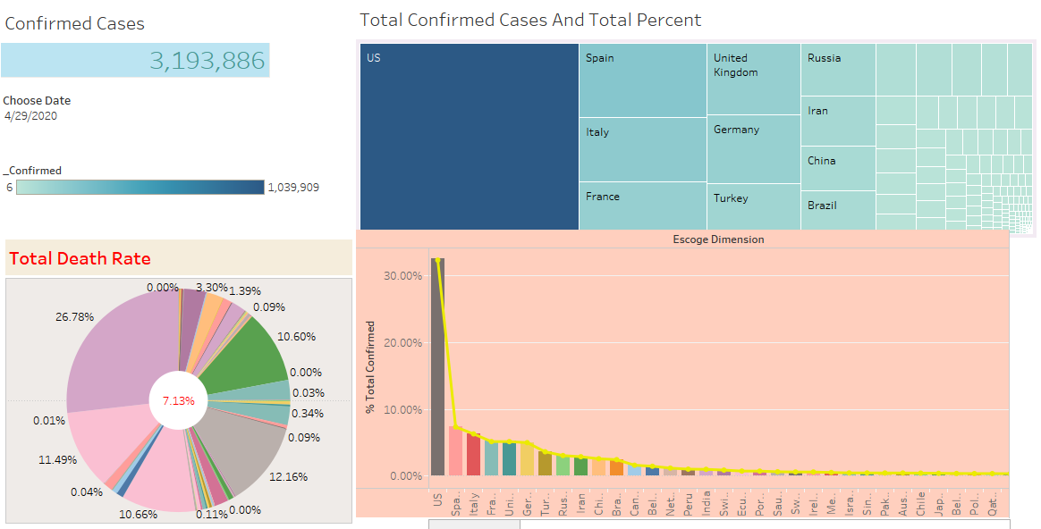
Description: The dashboard represents the number of total confirmed cases globally. It also depicts the total death rate in percentage for different countries. Mosaic plot shows occurrence in the countries mainly depicting the highest incidences of confirmed cases. Also the total confirmed cases are shows in column chart as percentage for the different countries.
Target audience: The target audience includes government, healthcare authorities, and citizens of these countries. It will spread awareness of the COVID confirmed countries relative to the total cases confirmed worldwide.
Purpose: Purpose of the dashboard is to inform about the total cases confirmed in different regions and the percentage of the incidence.
Information presented: The information presented shows the total number of COVID 19 cases confirmed around the world. It also depicts the percentage of the COVID cases in each country out of the total incidences.
Actionable insights: The actionable insights are that highest of the COVID cases confirmed globally is in United States with 26.78% of the overall incidence rate.
Benefit for decision making process: The decision making process is supported with the dashboards with benefit of learning about severity of confirmed cases and the largest number of cases. It will also support the healthcare organizations to offer support and provisions to reduce the cases. Also, the government of respective country will be able to understand about the case of the COVID 19 and undertake immediate emergency procedures during pandemic.
Dashboard 5:
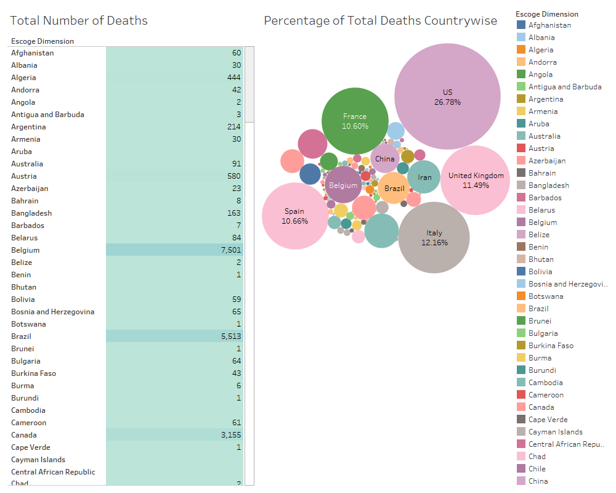
Description: The dashboard represents the bubble chart with cluster of circles showing prevalence of COVID deaths. The table shows the total deaths with the chosen dimension as country-wise representation.
Target audience: The target audiences are the global governments as well as governments of the respective countries.
Purpose: The purpose of the dashboard is to represent the countries with highest death rates in total. The dashboard provides sufficient information to learn about the critical situation of each country due to the corona virus pandemic.
Information presented: Information presented in the dashboard include total cases of COVID in each country in a table format. It also has a bubble chart with legends showing country having largest COVID cases as the largest bubble, followed by the second largest total deaths in second largest bubble and so on.
Actionable insights: It is learned that United States has the highest number of deaths in total followed by Italy with second highest rate of deaths in Italy, then United Kingdom closely followed by Spain and France.
Benefit for decision making process: The dashboard is used for decision making process to provision of support the pandemic. This can be used for making neighboring countries to take precautions, and make beneficial decision about offering support in time of the crisis. Also, the countries will find it beneficial to make decisions regarding business relations, imports, and exports etc.

Dashboard 6:
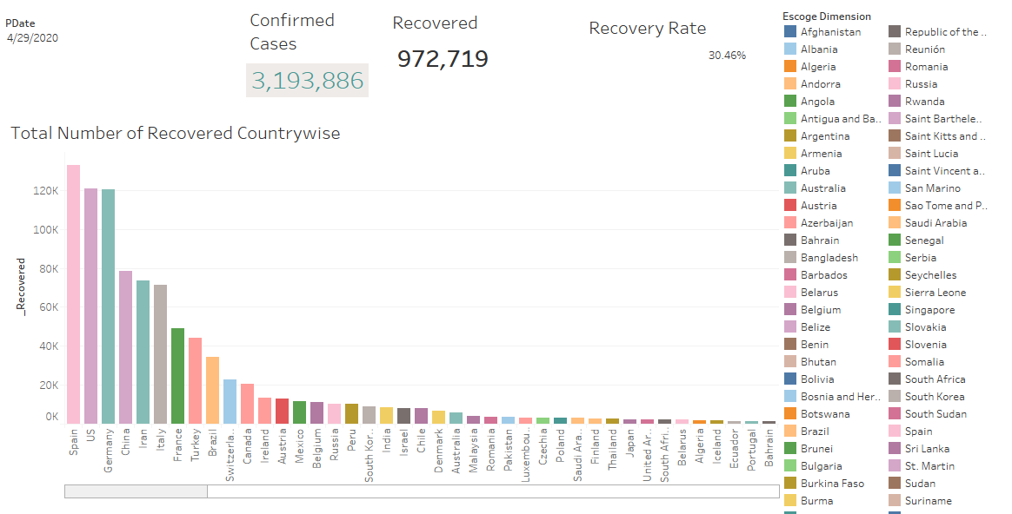
Description: The dashboard depicts the total confirmed cases around the world and the cases recovered globally. It also depicts the recovery rate globally and the number of cases that have totally recovered till date.
Target audience: The target audiences are the global healthcare organizations, government authorities, and large organizations that can use the data to offer support.
Purpose: The purpose of the dashboard is to depict the recovery around different countries around the world. It shows the total cases confirmed, recovered cases, and rate of recovery. The different recovery numbers for each country are also represented.
Information presented: The total number of cases recovered from the period during the period of 22nd January 2020 to May, 6th 2020 are represented globally. The separate recovery data per country are also depicted in graph.
Actionable insights: The actionable insights gained are that there are 972719 cases recovered globally. The highest recovered cases are recorded at in Spain, followed by US, Germany, China, Iran and Italy being the highest sets of recovery. On the contrary, countries like Ecuador, Portugal, and Bahrain shows lowest recovery date however it is important to know that it can be attributed to lowest cases registered in these countries.
Benefit for decision making process: The decision making process can be benefitted by using the date to observe the recovery rate from the dashboard with other dashboards relative to the confirmed cases and deaths in each country. It can be used to assess rate of response of the governments to the COVID pandemic.
Dashboard 7:
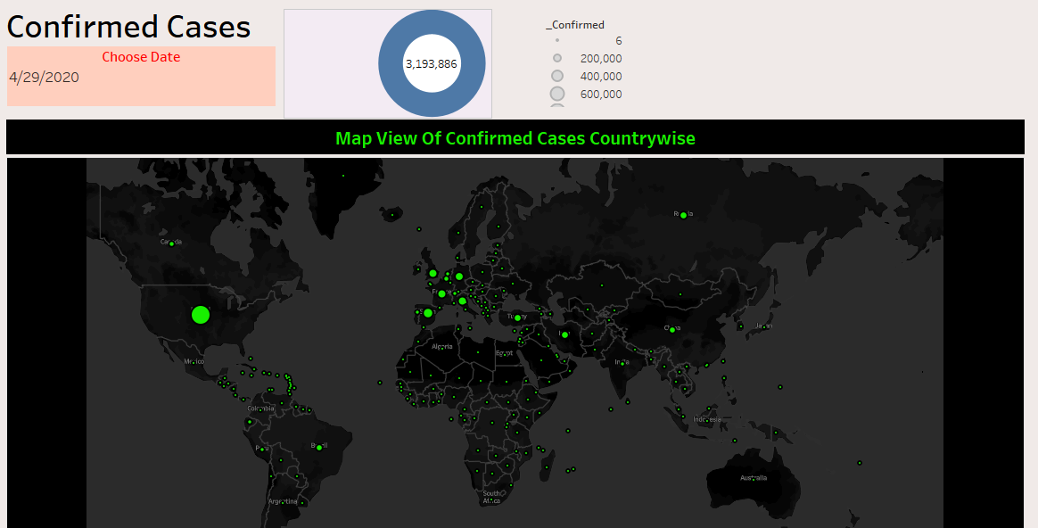
Description: The dashboard is a map view of the confirmed COVID 19 cases. It is a representation of the intensity of COVID in each country shown with the map.
Target audience: The target audiences are individuals to get quicker overview of problem scenario, government officials, media, and data analysts.
Purpose: The purpose of the dashboard is to represent the COVID cases confirmed in different countries by map. The cases confirmed are shown in fluorescent green for each country in the world map.
Information presented: The information presented shows the confirmed COVID cases in map with green circle showing the intensity of the incidence. The size of the circle differentiates the highest and lowest number of COVID cases confirmed in the countries.
Actionable insights: The actionable insights gained are the highest incidences with world map shown in different countries. The intensity of confirmed cases are shown with the size of the circle shown for each country in the world map.
Benefit for decision making process: The decision making process can be beneficial using the dashboard as the country officials can use it to assess their neighboring countries and take precautionary measures. They can be aware of incidences around their neighbors and the relative impact on their country as well as for offering support.
Dashboard 8:
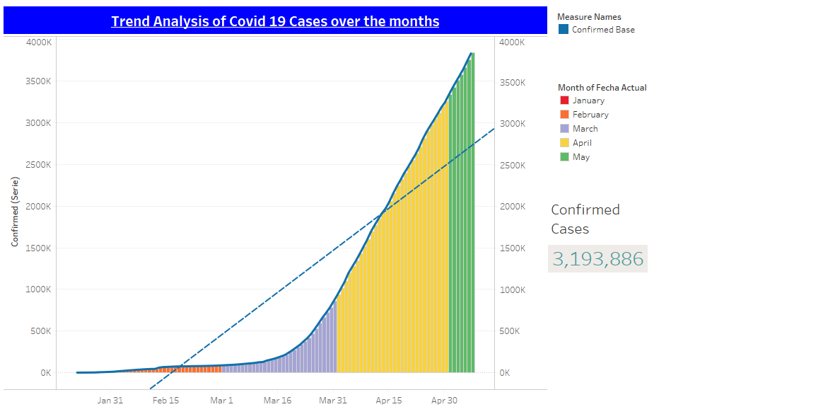
Description: The dashboard represents the trend analysis of the COVID cases for the months January through May. It also shows the trend line plotted with the data for different months on global COVID cases.
Target audience: The target audiences are the global governments, international businesses,
Purpose: Purpose of the dashboard is to represent the trend of COVID cases confirmed globally and the progress for the months of January through May.
Information presented: The information presented is sufficient to learn about the progress of COVID cases globally and growth during the year 2020 till date. It shows that the COVID cases registered during January to February slowly increased, and global confirmed cases rate steadily increased till mid-march and quickly surged after mid-march and increased at an alarming rate till May without substantial decrease.
Actionable insights: Actionable insights shows that the dashboard represents confirmed COVID cases were increasing substantially during the period of January to May, 2020. The period after Mid-March was the sudden upsurge of the COVID cases confirmed globally.
Benefit for decision making process: The decision making process is benefitted from using the dashboard is that global governments should strive to fight the pandemic. The trend shows that it is important for countries to not merely treat the patient but also initiate lockdown procedures to prevent movement in and out of the country. Also, it should be used for initiating research to find the appropriate cure for the disease.
Dashboard 9:
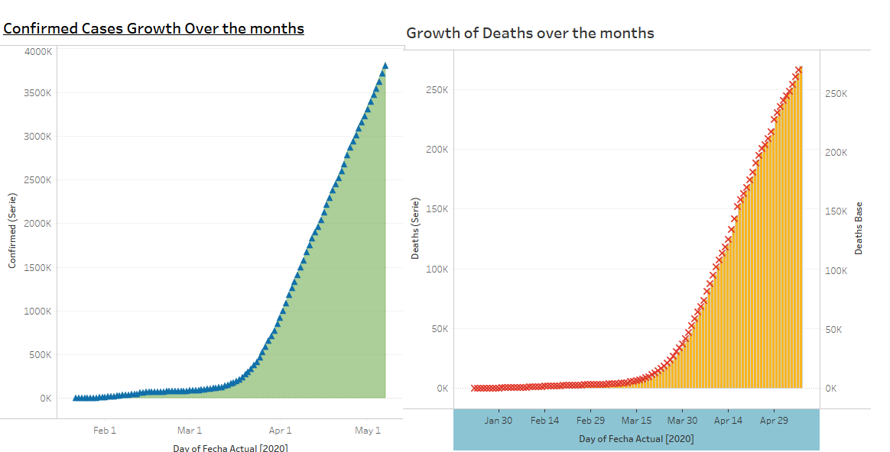
Description: The dashboard shows the growth of confirmed COVID cases and the COVID deaths globally. The two can be compared to make a comprehensive comparison of the growth rate of confirmed cases and the deaths that have occurred during the period.
Target audience: The target audiences of the dashboard are the respective governments who should take care of the problem, WHO that should research find the effective cure, and the people of the country that should adhere to the controls imposed.
Purpose: The purpose is to show the severity of the global pandemic and how it has claimed huge number of lives.
Information presented: The information presented shows the growth of the COVID cases as they were confirmed globally during January through May. It also represents the COVID deaths during the same period.
Actionable insights: It is interpreted that the global cases of the COVID pandemic increased and the parallel growth of the number of deaths that kept steadily climbing through the same period. This shows the severity of COVID confirmed cases and the death rate globally which increased substantially over the selected period of time.
Benefit for decision making process: The benefit of the dashboard to make decision is that it can be used for learning the increase in the COVID cases confirmed globally and take the preventive measures in all countries by the respective the government authorities. This will help to prevent the incidence in other countries.

Dashboard 10:
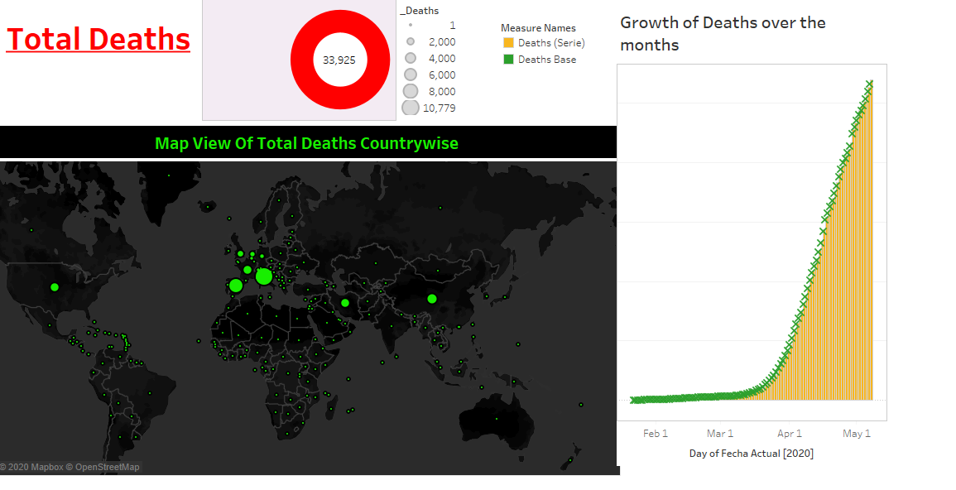
Description: The dashboard shows the total death rates globally in world map. It also shows the growth of COVID related deaths during January 22 to May 6.
Target audience: The target audiences are the governments and health authorities that should understand the alarming death rates to propose effective measures against the global pandemic.
Purpose: Purpose of the dashboard is to show how the death rates have increased globally during January to May.
Information presented: The information presented shows that the COVID deaths have grown substantially during the period. It also represents the deaths in world map with green circle. Higher death rate in the country is represented by the size of the circle shown for each country in the world map.
Actionable insights: The actionable insights are that the COVID deaths are increasing severely so, it is important for all countries to initiate stringent policies and measures to fight the spread of the COVID crisis.
Benefit for decision making process: It benefits the decision making process by depicting the highest cases of the deaths occurred globally in different countries. The benefits are derived by the countries that use the dashboard to learn about the high death rates and secure interactions as well as offer support to these countries.
Dashboard 11:
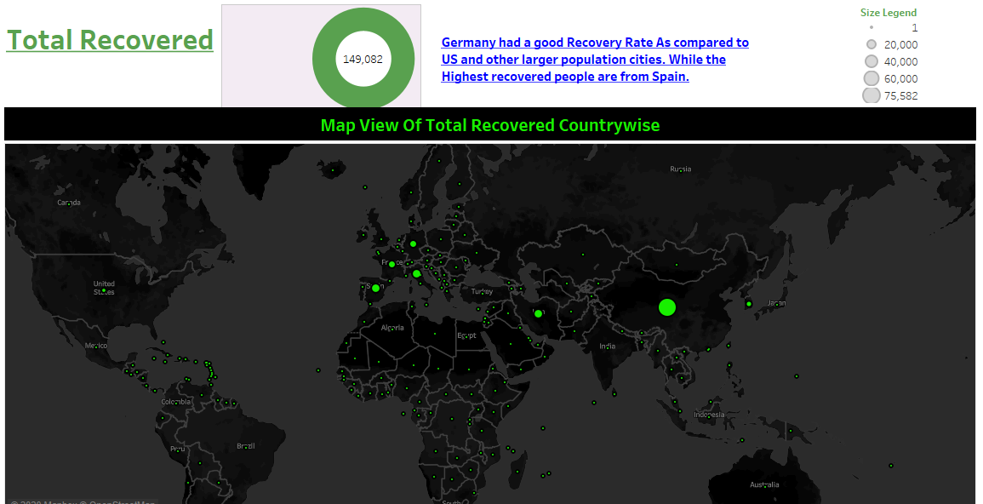
Description: The dashboard shows map view of the total cases that have recovered from COVID 19 globally. It is represented in the world map on the cases that have recovered globally in different countries.
Target audience: The target audiences of the dashboard are all countries that are affected by COVID, and those that have possibility to be affected from COVID.
Purpose: The purpose is to learn about the recovery rates of different countries around the world. It will depict the countries that has the highest to the lowest recovery rates from COVID crisis
Information presented: The information presented shows that good recovery rate is for Germany as compared to US and other countries. The highest number of people recovered in the country of Spain.
Actionable insights: The actionable sights are that some countries have attained good position against the global pandemic. It shows that these countries have effectively controlled the extent of the outbreak and reduce the cases of COVID19 confirmed in their countries.
Benefit for decision making process: The benefits of the dashboard to decision making process are that it will support the global governments to interpret the clinical intervention used for treating the patients and increasing recovery rates.
Dashboard 12:
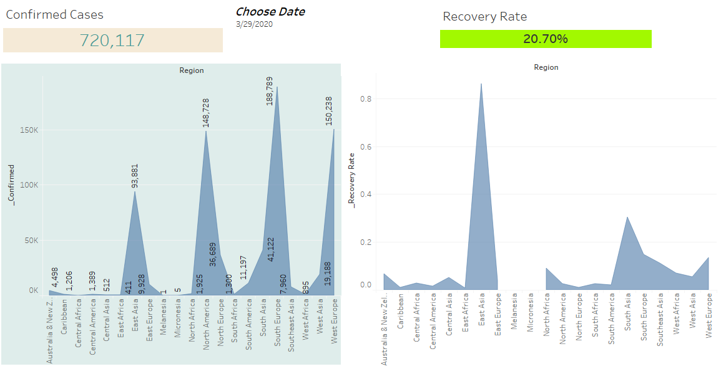
Description: The dashboard shows confirmed cases comparison compared with the recovered cases for each continents. It is shown with relevant legends represented with climber line chart type.
Target audience: The target audiences are the global health authorities that should interpret the cases confirmed and recovered cases to study the progress and countermeasures against the pandemic.
Purpose: The purpose is to represent how continents are fighting the COVID cases confirmed and treating the patients improving recovery rate.
Information presented: The information presented shows COVID incidence rate i.e. confirmed cases and recovery rate i.e. recovered cases in different continents.
Actionable insights: It is interpreted that South Europe has highest confirmed cases of COVID but the recovery rate is not adequate and East Asia has the highest recovery rate even rate among the four highest COVID confirmed continents.
Benefit for decision making process: It is beneficial to make decisions on supporting different continents and evaluating adequate preparedness of the continents against such global contingencies.
Dashboard 13:
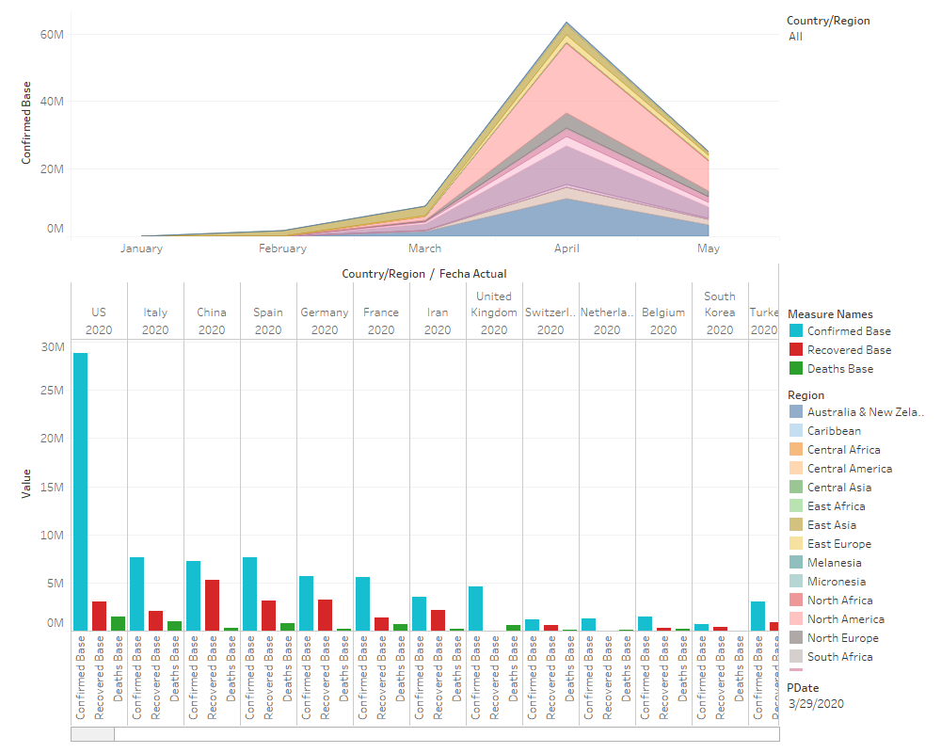
Description: The dashboard shows the area chart of different countries and the confirmed cases in the region. It also shows the comparative visualization of COVID confirmed cases, recovered cases, and deaths.
Target audience: Target audiences include the different global countries cumulatively learning the higher incidence and the governments as well as health organizations that offer support during the COVID crisis.
Purpose: The purpose is to show the countries that have higher confirmed cases as well as to perform a comparative analysis of the COVID total number of confirmed cases, recoveries and deaths occurred due to the pandemic in different countries.
Information presented: Information presented shows global incidence rate of COVID 19 in different countries. It also shows recoveries, confirmed cases and deaths that have occurred together for easier interpretation.
Actionable insights: The actionable insights are that US has highest cases confirmed but recovery rate is relatively very less. At the same time, death rates are also less. Italy has the second highest rates followed by Spain and China. Recovery rates of Italy is less and lesser are the death rates. But the death considering the lesser confirmed cases is not a good indicator. This is so in case of Spain and few other major countries. Some countries like Germany has attained good recovery rate with lesser deaths. This is so incase of countries like Iran, UK Switzerland etc.
Benefit for decision making process: The benefits of the dashboard to decision making process is that the dashboard can be used for making meaningful assessment about how the countries have fought the COVID crisis with a relative comparison of the confirmed cases, recoveries as well as deaths.
Dashboard 14:
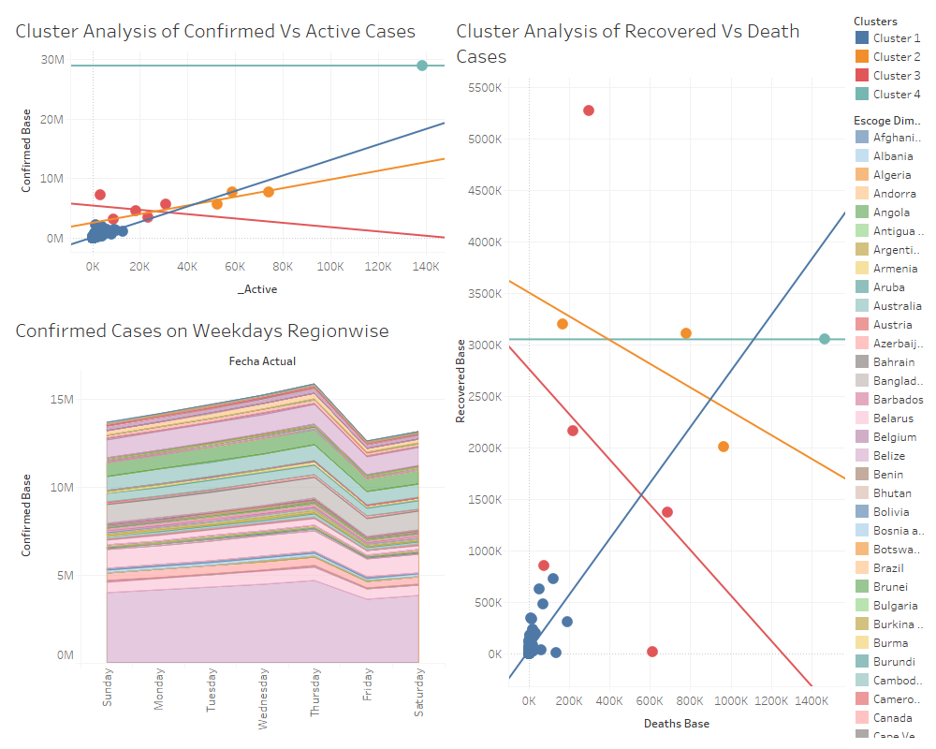
Description: The dashboard shows cluster analysis between confirmed cases and cases that are still active (confirmed less recovered less deaths). It also shows weekdays confirmed cases regionwise. The dashboard also performs cluster analysis between recovered COVID cases and the related deaths.
Target audience: The target audiences of the dashboard are the data analysts who want to make predictive analytics and interpret meaningful patterns from it.
Purpose: The purpose is to inform the audience about the cluster analysis of the COVID confirmed cases to assess the active cases ascertained as a new variable deducting recovered and deaths.
Information presented: The information presented shows COVID cases that are still active in the different countries. It also presents information about cases that are confirmed on week days in different region as well as cluster analysis of recovered COVID cases as well as Deaths in the regions.
Actionable insights: The actionable insights are learning the different clusters of various regions that were recorded for COVID cases confirmed, death occurred and the recoveries form the pandemic.
Benefit for decision making process: It is beneficial to decision making process for identifying countries with highest COVID spread from the clusters of confirmed cases. Also, it is used to learn about the cluster of countries that successfully recovered from the COVID pandemic.
Dashboard 15:
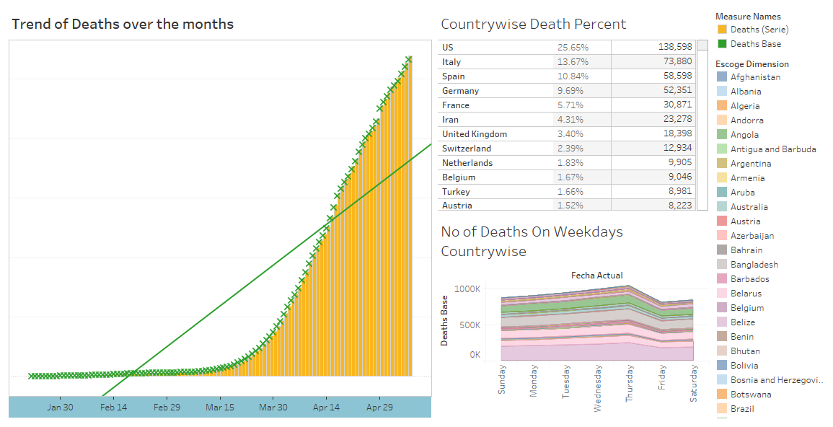
Description: The dashboard shows country wise death percentage along with number of deaths that occurred during week days. Also, the dashboard shows trend of COVID deaths during the period of January 2nd to May 6th, 2020.
Target audience: The target audience includes all countries, their government authorities, as well as the global healthcare organizations.
Purpose: The purpose of the dashboard is to show the percent of deaths that have occurred in each country, the trend of these deaths, and the deaths in different countries that occurred during week days.
Information presented: The information presented shows the COVID pandemic deaths and the rate out of the overall deaths globally for each of the countries. It also presents information of the death trends and the pattern of progress (increase/decrease) as well as number of week days with deaths registered for the countries.
Actionable insights: The actionable insights show the highest to lowest death rates of the countries which can be used for imposing adequate control in the countries with highest death rates and increased healthcare attention as well as resources to be contribute towards treating COVID patients.
Benefit for decision making process: It is beneficial to healthcare decision making process regarding adoption of new clinical intervention for treating the COVID patients in country with highest death incidence. Also, countries with low death rates can transform their proposed clinical interventions as adequate treatment intervention after proper medical research.

Reference;
Kaggle. (2020). COVID-19 Case Study - Analysis, Viz & Comparisons. Retrieved from https://www.kaggle.com/tarunkr/covid-19-case-study-analysis-viz-.comparisons/data

